Assignment 3: Maximum Likelihood Estimation

Step 1: Graphing the Relationship
- Python code and relationship between x and y graph

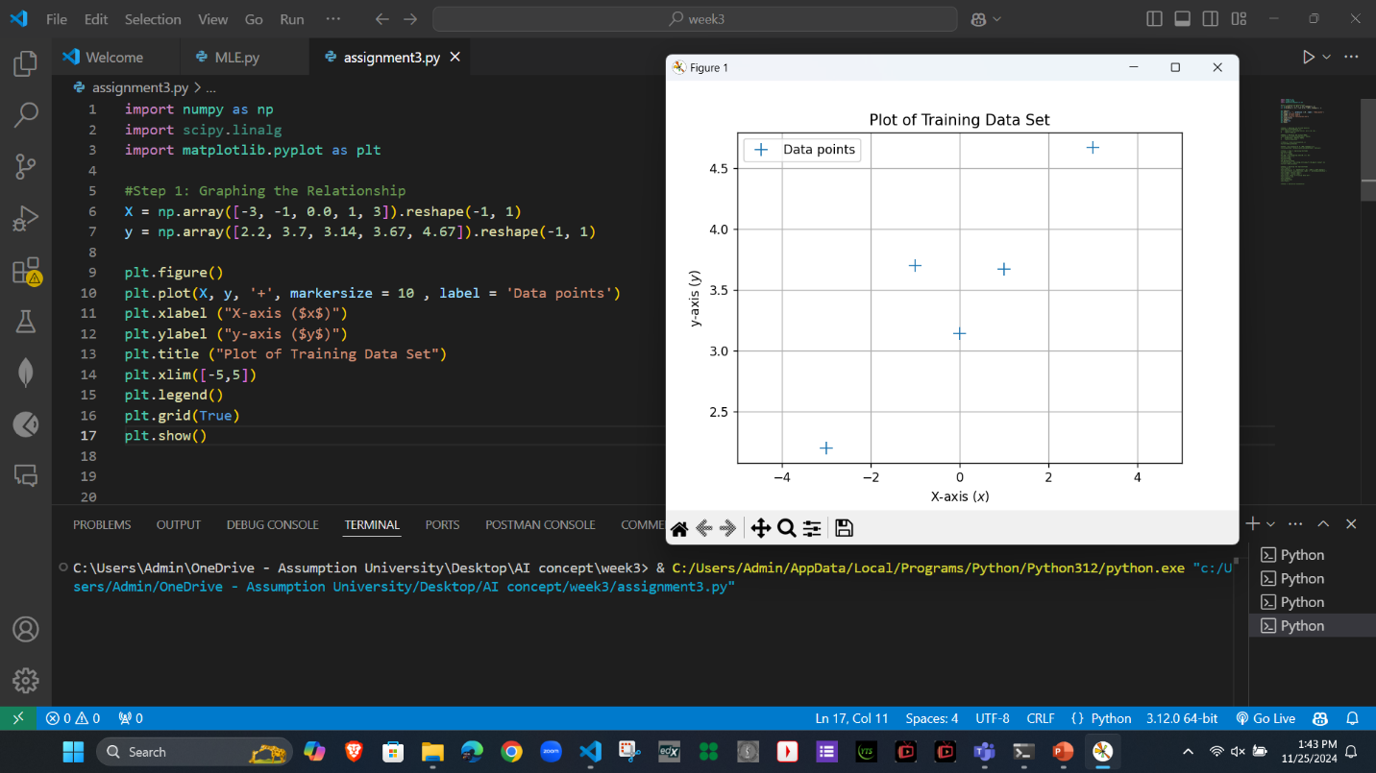

Step 2: Applying the Derived Equation

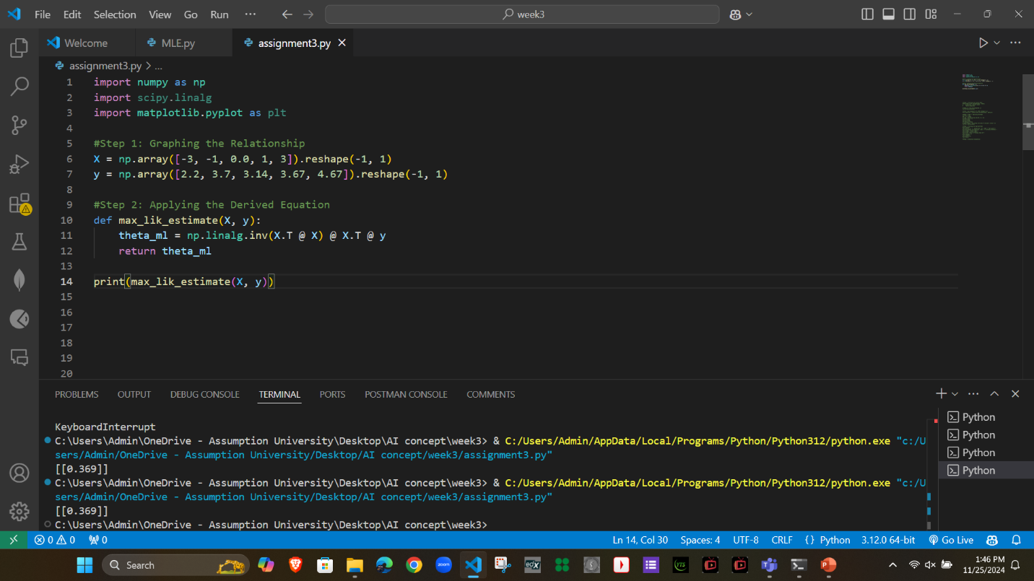
Theta value is 0.3689

Step 3: Plotting the Initial Model
- Applying Theta obtained from Step2 in Step3
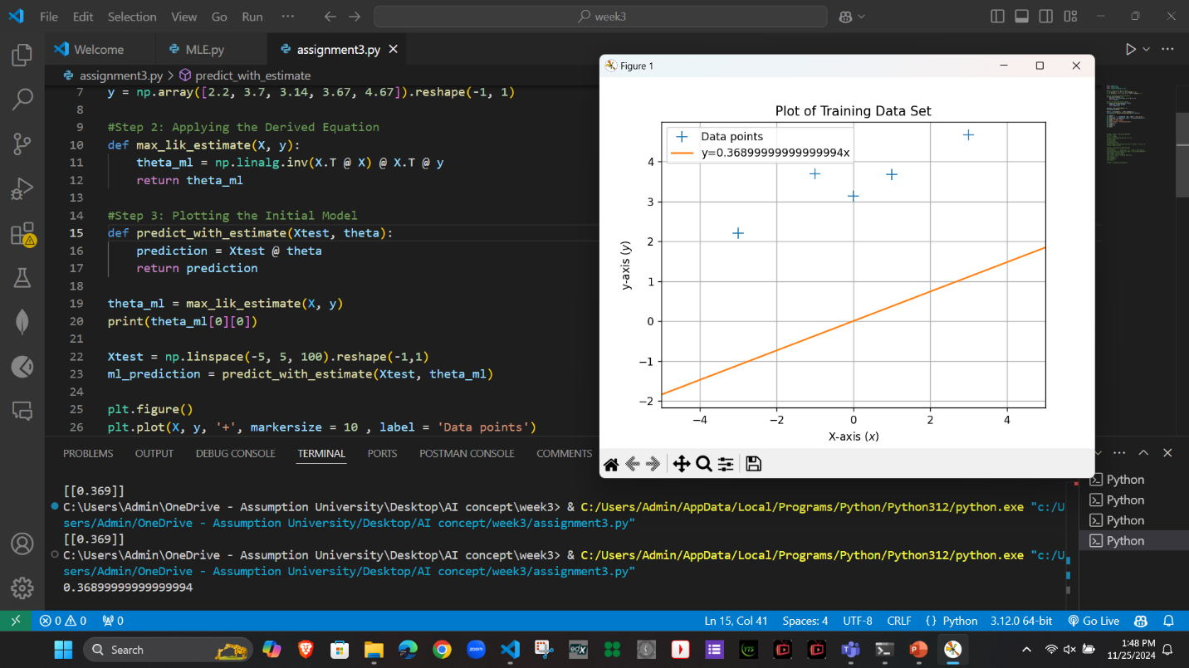

Step 4: Improving the Model
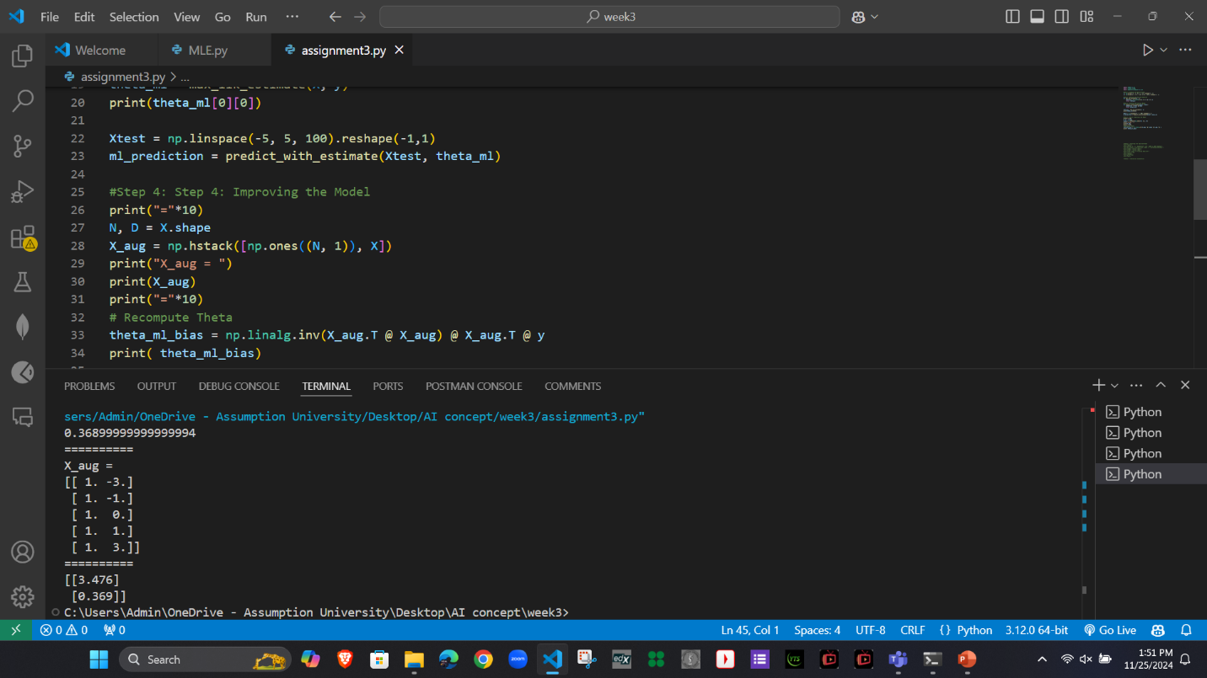
Theta values are 3.476 and 0.369
Explanation
In Step 2, the model assumes the line passes through the origin, so there is no intercept term. The parameter θml​ is solely the slope, which might not fully capture the relationship if the line does not pass through the origin.
In Step 4, by adding a bias term, the model accounts for a possible offset in the data. The resulting θml-bias​ includes both the intercept and slope, potentially providing a more accurate fit to the data.

Step 5: Plotting the Improved Model
- Use new Theta values from step4 in linear equation and plot the graph
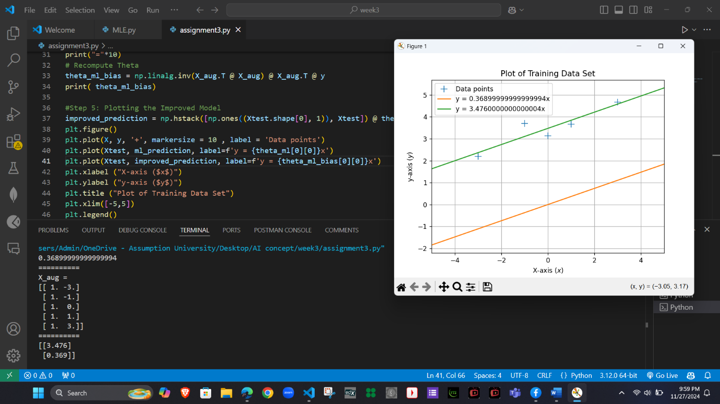
Step 6: Analytical Explanation
- Step 2 Limitation: Assumes the line passes through the origin (y=θx), which may not fit real-world data where y-intercept isn’t zero.
- Bias Term Role: Adding ones enables the model to estimate a non-zero intercept (y=θ0+θ1x), making it more flexible.
- Improved Fit: Accounts for vertical shifts, reducing residual errors and better aligning the line with the data.
- Broader Model Capability: Supports relationships with both slope and intercept, fitting a wider range of linear patterns.
- Mathematical Impact: Minimizes errors by recalculating parameters (θ0 and θ1) for a closer match to data.

